TopCoder Copilot Pool Front End Assembly Deployment Guide

Revision History
Author | Revision Number | Date
TCSDEVELOPER | 1.0 | 08/21/2010

Deployment Instructions 3
1. Organization of Submission 3
2. Application Setup 4
3. Database Setup 5
4. Deployment Instructions 5
5. Starting 5
6. Verification 6
7. Resource Contact List 8

Deployment Instructions

Organization of Submission

The submission has following directory structure:

docs

Contains this document which is the Deployment Guide for the TopCoder Copilot Pool Front End assembly.

resources

Contains the configration file for TopCoder Website application with some configuration parameters added, used to initialize Constants.java class (in TC.properties).

Contains a updated web.xml for TC site which has spring integrated into the web application.

Contains a newly added applicationContext.xml which is used by spring to load service creation configuration, the CopilotProfileService implementation is configured in this file.

db_scripts

Contains there kinds of SQL scripts
- DDL scripts : the scripts setup the database with schema required for copilots
- Query scripts: contains the new queries which should be added via Topcoder Query Tool
- Test Data scritps: contains the test data which can be used to test this assembly.

See database setup section for details.

static

Contains the static resources (CSS, Javascritps and Images) that are newly introduced in this assembly. They should be copied to the apache HTTP service during the deployment, see the following section for details

src

main

Contains the updated and newly added sources for classes and views during this assembly.

test_files

Contains the test_files which are needed to test this assembly. It contains two sample spring configurations, one for Mock implementation, the other one for Sql implementation.

It also contains an image directory which should be copied to the Apache service to test the header image rendering of the copilots.

copilot pool and profiles services

This directory provides a component structure for the two implementations of
CopilotProvideService, it contains the ant scripts to compile and package it as a component named copilot_pool_and_profile_services.jar. So that it can be deployed to the service and used like a topcoder component.

build_tc.xml

The update ant script for buidling and deploying TC websites.

Application Setup

The TopCoder Copilot Pool Front End Assembly is expected to be integrated into existing TopCoder Website application.

New static fields were added to Constants class, and thus new configuration parameters have been added to TC.properties file.

The web.xml for the TC web site has been changed during the assembly, the following fragment has been added to have the spring integrated into the TC website.

<context-param>
<param-name>contextConfigLocation</param-name>
<param-value>WEB-INF/applicationContext.xml</param-value>
</context-param>

<listener>
<listener-class>org.springframework.web.context.ContextLoaderListener</listener-class>
</listener>

A new file applicationContext.xml has been added, which is the spring configuration file for loading CopilotProfileService instace. After deploying, it should under the directory WEB-INF, the same as web.xml.

Database Setup

To update the existing databases to reflect the changes introduced with this assembly do the following:

- In the database tcs_catalog, run the script 1_copilot_pool_ddl.sql to create new schema.
- In the database tcs_catalog, run the script 2_copilot_profile_type_setup.sql to insert the look up values for copilot profile types.

You need to insert test data (contains new users, new coders, copilot pool data, coder ratings, and user images information) to fully test this assembly

- To insert the test data, you need to run the script 3_copilot_pool_test_data.sql to insert them all.

There are two queries newly introduced in this assembly, you need to correctly add them via TopCoder Query Tool to make this assembly work.

- To access the TopCoder Query Tool, make sure your VM is running and configure correctly and access http://tc.cloud.topcoder.com to login first (usr:heffan / pwd : password).
- After login, you can access http://tc.cloud.topcoder.com/query/query to create the new queries:
  - The two queries are put under db_scripts/query directory
  - You should select TCS Catalog in the DB selection of query tool
  - Click new command to create a new command called copilot_pool_members, select the group Util, then save.
  - Click New Query to create two new queries, the contents of the queries are in the SQL files mentioned before:
Query name | SQL file name | Description
copilot_pool_members | db_scripts\query\copilot_pool_members_QUERY.sql | This query will be used by the SqlCopilotProfileService to get the copilot pool members
copilot_pool_images | db_scripts\query\ copilot_pool_images_QUERY.sql | This query will be used by the ViewCopilotPool request processors to retrieve copilot image paths from the persistence
  - After creating the two new queries, you need to add them into the command copilot_pool_members

Deployment Instructions

This section provides the instructions for integrating this assembly within the environment provided on Cloud VM instances.

- Unpackage the submission archive to some temporary directory.
- Copy css, images, and js sub-directories from static directory to /usr/local/apache/tcdocs directory.
- Copy images sub-directories from test_files directory to /usr/local/apache/tcdocs directory. It contains the user images for testing purpose.
- Copy lib, resources, src directories and build_tc.xml file to /home/tc/web directory.

Then you need to build and deploy tc app and distui app in order

First you need to run ant -f build_distui.xml clean under the login distui in /home/distui/web

Then to deploy tc app, login into the VM with username tc

- Use command killall java to shutdown the Jboss first
- Then run ant –f build_tc.xml deploy under the directory /home/tc/web to deploy the tc
- Then use jbb to go to the JBoss bin directory, and use ./start.sh to start the Jboss

Finally to deploy distui app, login into the VM with username distui

- Use command killall java to shutdown the Jboss first
- Then run ant –f build_distui.xml deploy under the directory /home/distui/web to deploy the distui
- Then use jbb to go to the JBoss bin directory, and use ./start.sh to start the Jboss

Starting

- Deploy the TopCoder Website (tc) and TopCoder UI (distui) I application
- Start JBoss server instance as described in section 4 (consult the VM Member Instructions document available at http://www.topcoder.com/wiki/display/docs/VM+Image+2.1.5)
- Note that after running the SQL script to insert test data or after adding new queries into the TopCoder query tool, you may need to refresh the cache be restarting cache JBoss server instance.

Verification

Note on test data:

After running the SQL script (3_copilot_pool_test_data.sql) to insert the test data, you should have users with id 10000 to 10100 that are inserted into the database. And the users with id 10001 to 10100 are all added into the copilot pool. The ratings of the users are inserted randomly, so that you will see different rating colors. Part of the users have the images path inserted which randomly point to the 4 images used for testing.

To verify the deployment, first you need to go to the http://tc.cloud.topcoder.com/tc , the home page should be displayed correctly. And click the Copilot Opportunities, you will see the new added Copilot Pool link:

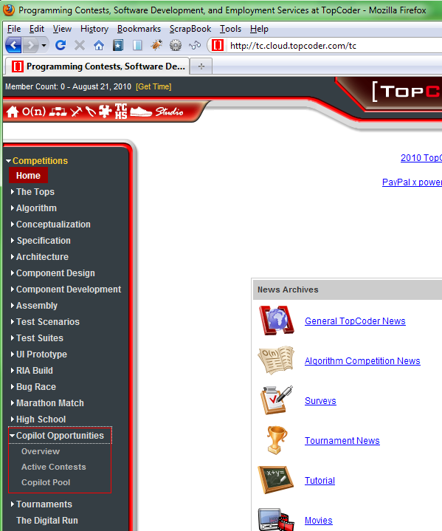

Click the copilot pool link, the grid view of the copilot pool will be displayed, with default ordering and default page size 10.

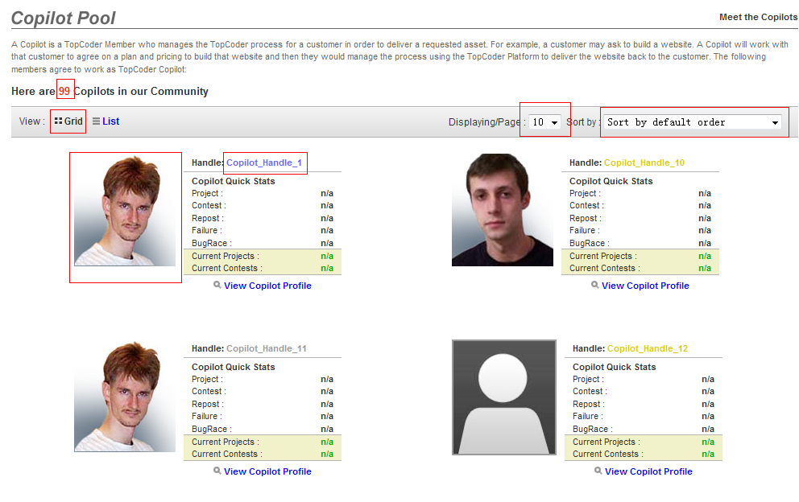

In the rendered page, you will see
- The number of copilots is displayed in the left upper corner,
- The default paging size is 10, and the default order is populated in the selection box.
- The Copilot handle colors are based on their highest rating.
- The Copilot’s header image is displayed, if the user does not have header image, a default one will be displayed.
- The view copilot profile is not clickable because it has not been implemented yet.
- The default view mode is grid.

Then you can play with the Page control and sort control, the page size can be switched between 10, 20 and 30. There are 9 sort types. You also need to test the page switches at the bottom of the page



To view the copilots in list view, you can click the List to switch. The current page size and sorting method will be maintained because you are only switching the view. After switching to the list view, you will see the copilots are listed in the table:

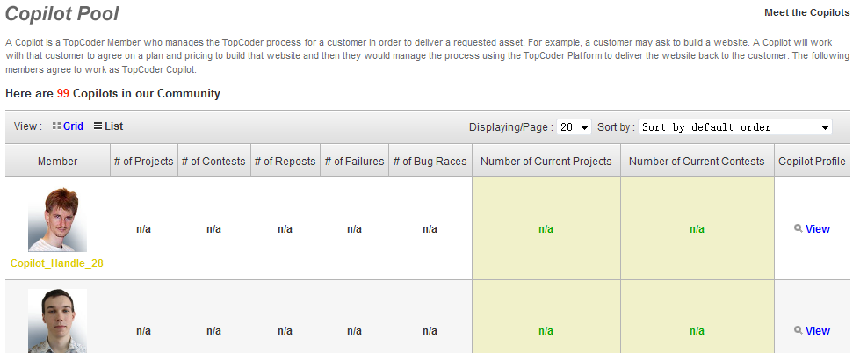

To test the sorting, it’s recommended you switch to use MockCopilotProfileService for testing because in the SqlCopilotProfileService, all the copilot statistic data is set to n/a, but MockCopilotProfileService has randomly generated data for the copilots.

Here is a view after switching to use MockCopilotProfileService (you need to modify applicationContext.xml file, redeploy and restart the jboss)

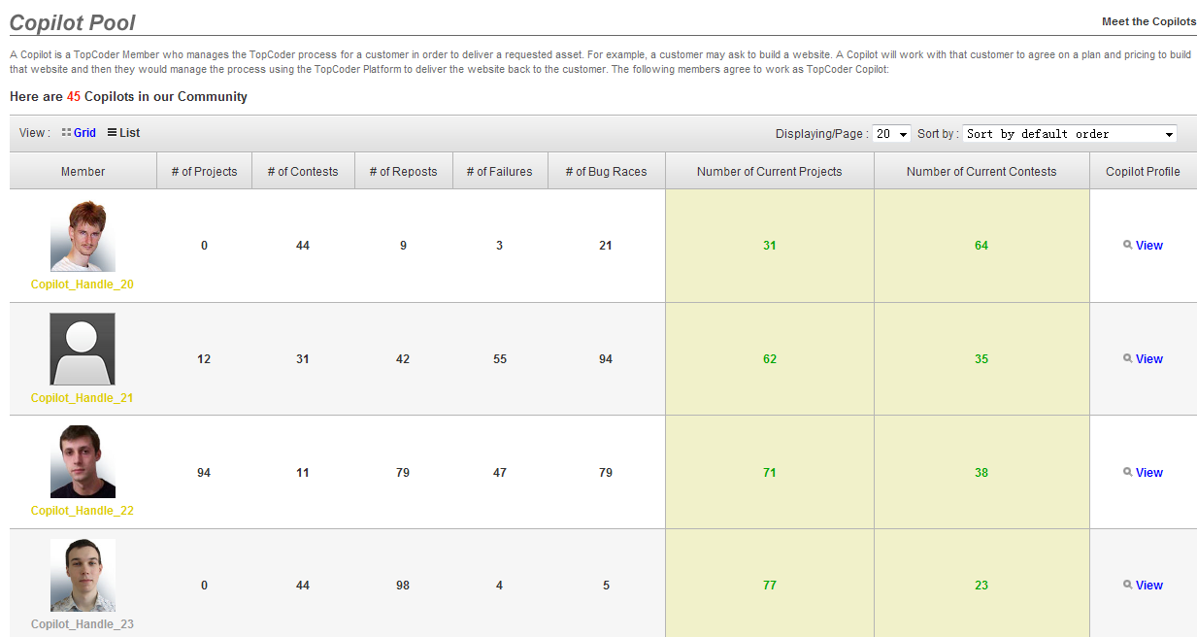

You can click the headers for sorting (there are 7 headers that can be sorted):
- # of projects
- # of contests
- # of reposts
- # of failures
- # of bug races
- # number of current projects
- # number of current contests
When you click a header, it will be sorted ascending:

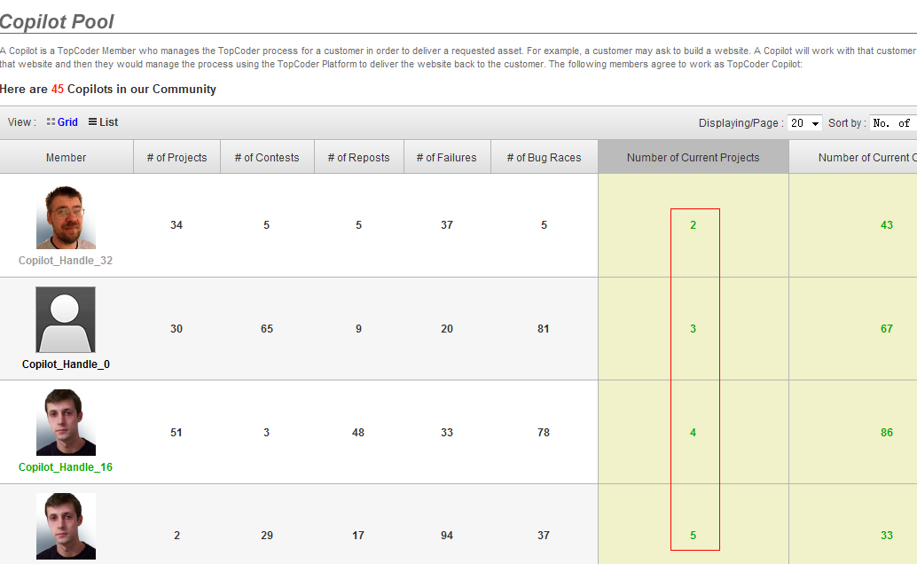

When you click the header again, it will be sorted descending.

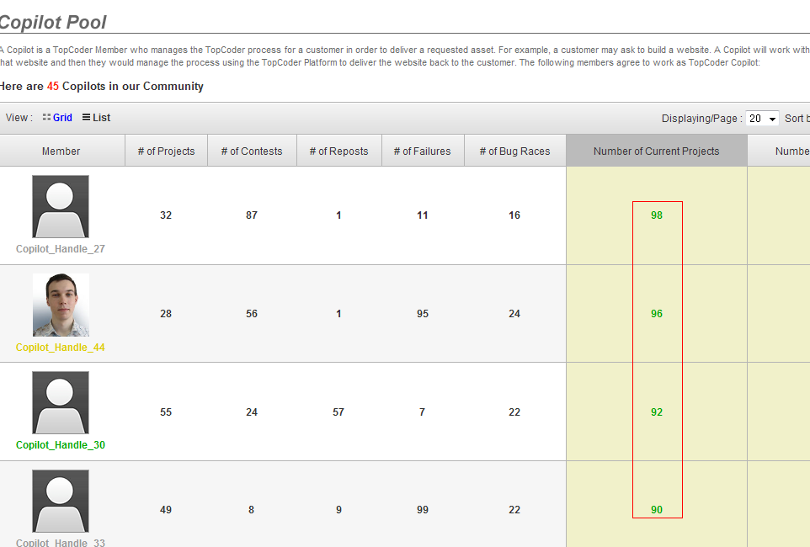

And you can also sort by drop-downs, and a nice feature added is that when you choose a drop down sorting, the sorted column header will also be highlighted, and vise versa.

Resource Contact List

Name | Resource Email
TCSDEVELOPER

